Deep learning is transforming the financial industry by enabling institutions to analyze massive, complex datasets, predict market trends, and manage risk with remarkable precision. Unlike traditional models, it leverages layered neural networks to process both structured and unstructured data like news, social media, and historical prices unlocking insights that were previously out of reach. As financial data continues to grow in volume and complexity, deep learning provides powerful tools for algorithmic trading, fraud detection, and portfolio optimization.
Deep learning is a subset of machine learning that uses artificial neural networks (ANNs) with multiple hidden layers to analyze large, complex, and unstructured financial data such as prices, transactions, text, and images
Advantages of Deep learning in finance
Handles large & complex datasets
Captures non-linear market behavior
High prediction accuracy
Real-time decision making
Y=F(^{XTw}+c)
- X represents the input data
- w represents the weights
- c represents bias
- F is an activation function such as sigmoid, ReLU, or tanh.
In financial applications, Y might represent a predicted stock price, credit risk score, or portfolio return. By stacking multiple layers of perceptron, we form deep neural networks (DNNs) capable of modeling intricate relationships
In financial applications, Y might represent a predicted stock price, credit risk score, or portfolio return. By stacking multiple layers of perceptron, we form deep neural networks (DNNs) capable of modeling intricate relationships
While traditional Neural Networks like MLPs or feedforward networks do not account for temporal patterns, financial data often comes in time series form. To address this, models like recurrent neural networks (RNNs) and long short-term memory networks (LSTMs) are used. These architectures are designed to capture sequential dependencies, making them ideal for financial forecasting.

Applications of Deep Learning in finance

1. Exchange Rate Forecasting
Exchange rate forecasting involves predicting how the value of one currency will change compared to another. This is necessary for international trade, investment, and monetary policy decisions. Deep learning models like Deep Belief Networks (DBNs) can uncover hidden patterns in complex and noisy financial data better than traditional models such as ARMA or SVM. By combining neural networks with tools like chaos theory or optimization algorithms, researchers have developed hybrid models that further improve prediction accuracy.

2. Stock Market Prediction
We aim to forecast future stock prices or market movements based on historical data, news, or investor sentiment. Accurate predictions can help investors make better trading decisions. Deep learning models like CNNs and LSTMs can process large volumes of data like stock prices, trading volumes, and even news articles to detect patterns over time. They can also understand context and sentiment from financial texts, making them more effective than basic machine learning techniques.

3. Algorithmic and Quantitative Trading
Algorithmic and Quantitative Trading involves creating automated systems that buy or sell assets based on mathematical models and data signals, aiming to profit from market inefficiencies. LSTM networks are used for handling time-series data, help in understanding market trends over time. Reinforcement learning (RL) models can simulate trading as a decision-making game, learning strategies by interacting with market data similar to how a human trader would learn from experience.
Mapping Deep Learning in Financial Services and Trading

4. Banking Risk and Credit Scoring
Our task here is to assess how likely a borrower is to default on a loan, or detecting fraud in financial transactions. Accurate models are key to reducing financial losses for banks. Models like FNN, CNN and LSTM are capable of learning subtle patterns in user behavior or transaction histories that indicate risk or fraud. For instance, LSTMs can spot unusual sequences in credit card usage, while CNNs can pick out important features in a customer’s financial profile, improving credit scoring accuracy.

5. Portfolio Optimization and Management
Portfolio management involves choosing the best mix of investments (like stocks, bonds, etc.) to maximize returns while managing risk. Advanced models like RNNs and RL algorithms can adapt to changing market conditions and learn strategies to balance risk and return. These systems can make dynamic decisions, such as adjusting investments in real time, while accounting for transaction costs and risk preferences.

6. Macroeconomic Forecasting
Macroeconomic Forecasting involves predicting large-scale economic events like recessions, financial crises, or inflation trends. It helps policymakers and financial institutions plan ahead. Deep learning models can process vast and varied datasets like employment rates, GDP, and global news. They can learn patterns that may signal an upcoming economic event. These models have shown higher accuracy than traditional methods like decision trees or logistic regression in anticipating such changes.

7. Commodity and Price Forecasting
Commodity and Price Forecasting refers to predicting the future prices of commodities such as oil, gold. or natural gas, which is important for budgeting, hedging and trading strategies. By combining models like MLPs, wavelet transforms, and SVMs, hybrid deep learning systems can handle the complex, nonlinear trends typical of commodity markets. These models are better at adapting to sudden price shifts or seasonal patterns than conventional forecasting methods.

Applied Deep Learning - LSTM based Stock Trend Prediction
Following example demonstrates a deep learning-based approach to stock trend prediction, using Apple Inc. (AAPL) stock data. The goal is to predict whether the stock price will go up or down the next day, which is a common binary classification problem in quantitative finance. Here we employ a Long Short-Term Memory (LSTM) network to model temporal dependencies in stock prices and trends. A correlation heatmap finally helps in visualizing relationships between input features and the stock price.

Step-wise Implementation

1. Import Libraries
We start by importing libraries for data loading, processing, visualization, feature scaling, model building, and evaluation. Yfinance is used to download historical stock data, Keras helps us build the LSTM model.
import yfinance as yf
import pandas as pd
import numpy as np
import seaborn as sns
import matplotlib.pyplot as plt
from sklearn.preprocessing import MinMaxScaler
from sklearn.metrics import mean_squared_error, confusion_matrix
from keras.models import Sequential
from keras.layers import Dense, Dropout, LSTM

2. Download Historical Stock Data (AAPL)
We fetch Apple Inc.'s OHLCV (Open, High, Low, Close, Volume) data from Yahoo Finance.
dataset = yf.download("AAPL", start="2023-01-01", end="2025-06-05")
print(dataset.columns)
Output:
Apple dataset columns

3. Adjust OHLC Data
As Yahoo already provides adjusted close prices, we simply use a dummy adjustment factor of 1 here. In real cases (like dividends/splits), you would use actual adjustments to normalize values.
dataset['adjustment'] = dataset['Close'] / dataset['Close']
dataset['Adj Open'] = dataset['adjustment'] * dataset['Open']
dataset['Adj High'] = dataset['adjustment'] * dataset['High']
dataset['Adj Low'] = dataset['adjustment'] * dataset['Low']

4. Feature Engineering
The model begins by computing the average of the adjusted Open, High, and Low prices to summarize daily price movement. It then includes the actual Close price to capture end-of-day market sentiment and calculates the daily return as the percentage change from the previous day. These three components are combined to form the feature matrix X, which serves as the input for the deep learning model.
- Label Creation:
  - Define the label as 1 if the next day's return is positive (up
- Label Creation:
  - Define the label as 1 if the next day's return is positive (uptrend), else 0 (downtrend).
  - This turns the task into a binary classification problem.
- Normalization:
  - Scale all features to the [0, 1] range using MinMaxScaler.
  - Helps improve training stability and speed for deep learning models.
- Data Cleaning:
  - Stack the features and labels together.
  - Remove any rows with NaN values caused by return calculations.
OHLCV_mean = dataset[['Adj Open', 'Adj High', 'Adj Low']].mean(axis=1)
close_val = dataset['Close']
returns = dataset['Close'].pct_change()
​
X = pd.concat([OHLCV_mean, close_val, returns], axis=1)
X.columns = ['OHLC', 'Close', 'Returns']
X = X.to_numpy()
​
#alabel constructions
Y = (np.sign(np.roll(X[:, 2], shift=-1)) + 1) / 2
​
#Normalization
scaler = MinMaxScaler(feature_range=(0, 1))
X = scaler.fit_transform(X)
​
#Data cleaning
XY = np.concatenate([X, Y.reshape(-1, 1)], axis=1)
XY = XY[~np.isnan(XY).any(axis=1)]

5. Train-Test Split
We reserve 75% of the data for training and the remaining 25% for testing.
Features and labels are then separated for both sets.
train_XY_len = int(XY.shape[0] * 0.75)
trainXY, testXY = XY[:train_XY_len], XY[train_XY_len:]
​
trainX = trainXY[:, :3]
trainY = trainXY[:, 3]
testX = testXY[:, :3]
testY = testXY[:, 3]

6. LSTM Model
- Reshaping for LSTM Input: Input data is reshaped to (samples, 1, 3) to match LSTM's expected 3D format with one time step.
- Building the LSTM Model: A four-layer LSTM network is built with 50 units per layer and dropout (20%) to reduce overfitting.
- Output and Compilation: A final dense layer outputs predictions, later thresholded for classification. The model uses Adam optimizer and MSE loss with accuracy as a metric.
- Training the Model: The model is trained for 10 epochs with a batch size of 1; this can be tuned for better performance.
#Reshaping for LSTM model
trainX = np.reshape(trainX, (trainX.shape[0], 1, trainX.shape[1]))
testX = np.reshape(testX, (testX.shape[0], 1, testX.shape[1]))
step_size = 3
​
#Defining LSTM Model
classifier = Sequential()
classifier.add(LSTM(units=50, return_sequences=True, input_shape=(1, step_size)))
classifier.add(Dropout(0.2))
​
classifier.add(LSTM(units=50, return_sequences=True))
classifier.add(Dropout(0.2))
​
classifier.add(LSTM(units=50, return_sequences=True))
classifier.add(Dropout(0.2))
​
classifier.add(LSTM(units=50))
classifier.add(Dropout(0.2))
​
#Output layer compilation
classifier.add(Dense(units=1))
classifier.compile(loss='mean_squared_error', optimizer='adam', metrics=['accuracy'])
​
#Training the Model
classifier.fit(trainX, trainY, epochs=10, batch_size=1)

7. Make Predictions & Evaluate
trainPredict = classifier.predict(trainX)
testPredict = classifier.predict(testX)
Output:
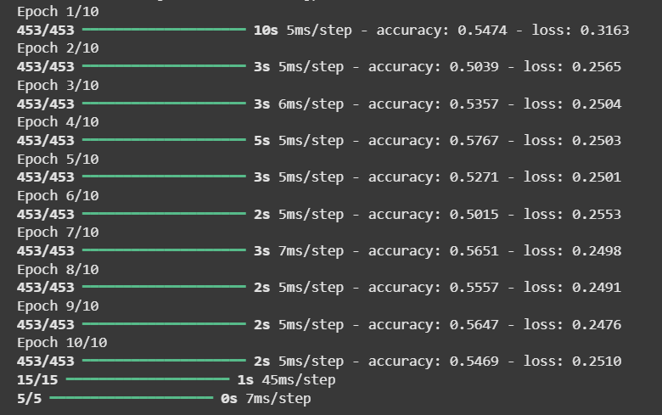Iterations depicting accuracy and loss over data

8. Plot Correlation Heatmap
correlation_matrix = X[:, :-1] # Exclude target
correlation_df = pd.DataFrame(correlation_matrix, columns=['OHLC', 'Close', 'Returns'])
correlation_df['Price'] = dataset['Close'].values[:len(correlation_df)]
​
correlation = correlation_df.corr()
​
plt.figure(figsize=(8, 6))
sns.heatmap(correlation, annot=True, cmap='coolwarm', fmt='.2f', linewidths=0.5)
plt.title("Correlation Heatmap: Features vs. Price (Close)")
plt.show()
Output:
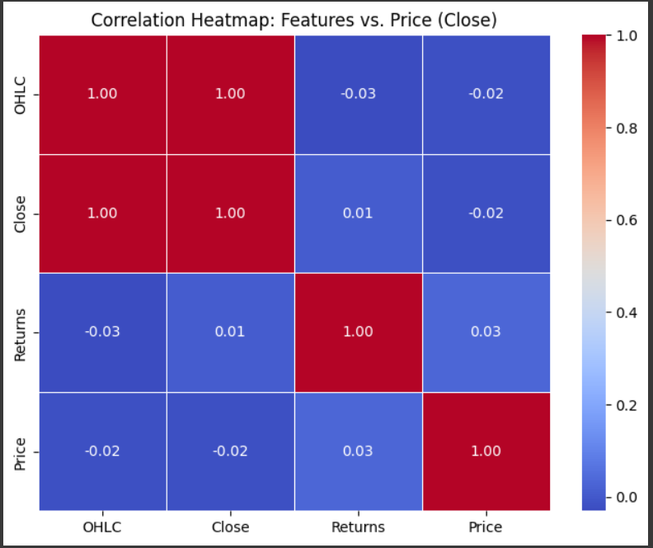Feature importance w.r.t actual Stock Price
We then calculate and plot the correlation matrix to understand how features relate to the actual stock price. This helps in assessing feature importance or selection in future iterations. Though simple this showcases how LSTM networks can be used to predict stock price trends using historical data. By engineering features like average OHLC values, close prices, and returns, and reshaping the data for sequence learning, a binary classification model is built to forecast market direction. The model demonstrates the potential of deep learning in financial prediction and can be extended with more features and tuning for better performance.

